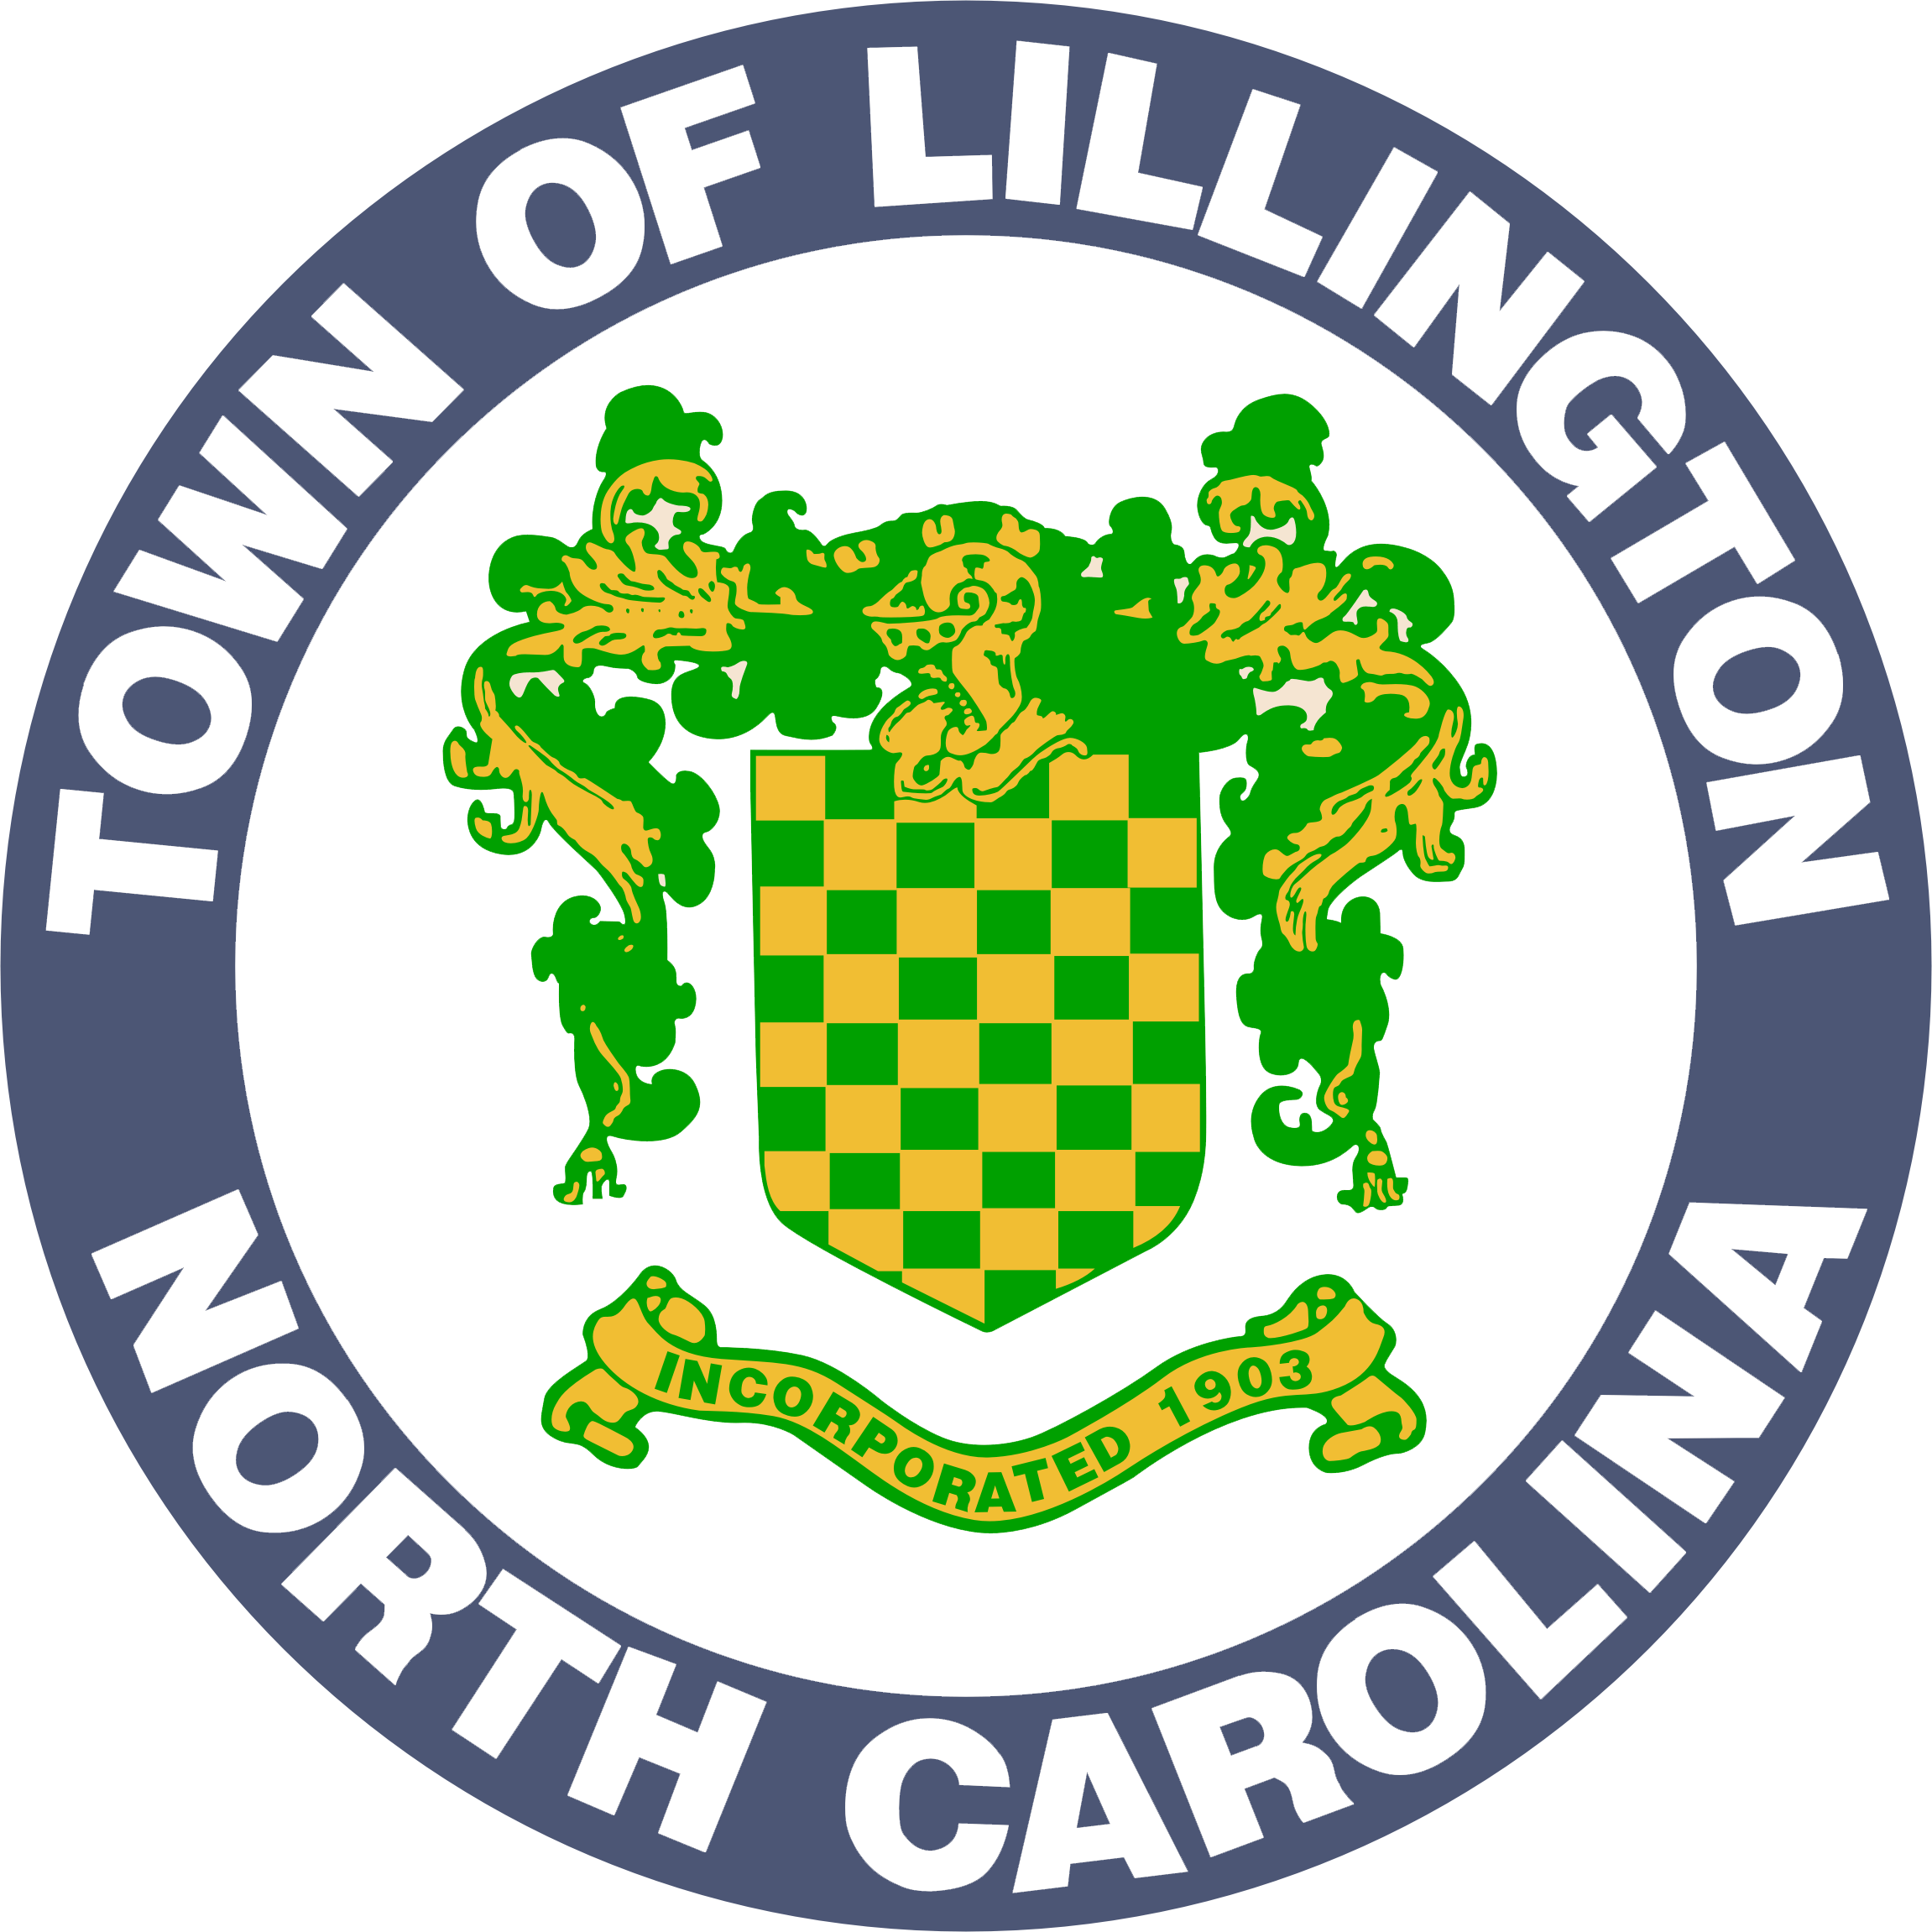

**UTILITY SERVICES & WASTE COLLECTION POLICY**

The Lillington Public Works Department provides water, sewer, waste collection and recycling services to residents and businesses within the corporate limits. This policy explains the administrative process, service details and regulations for the provision of these services.

**BILLING**

Billing is conducted once a month. The first bill for new accounts may be delayed one billing cycle depending on when the account is activated. Payments are due on the 15th of each month and payable until the 20th without any penalties. If the 20th falls on a weekend or holiday, then the due date extends to the next working day by 5:00 p.m.

**PAYMENT OPTIONS**

Payments may be made in-person at Town Hall,Mondays through Fridays between 8:00 a.m. and 5:00 p.m., excluding holidays. Payments can also be made online using a debit or credit card at lillingtonnc.org/utilityservices. The town also offers bank drafting as a payment option. Bank drafts are drawn on the 10th of each month. A drop-off box is available at Town Hall for after-hours payments. All after-hour payments will be applied to the account on the following business day. The phone number for Town Hall is 910-893-2654.

**PENALTIES**

Penalties begin to accrue on the 21st day of each month. A Late Fee of $10.00 or 5% of the current bill amount, whichever is greater, is added to all delinquent accounts. On the 26th of each month, a $40.00 Service Interruption Fee is assessed for all delinquent accounts not paid in-full by 5:00 p.m. on the 25th. Disconnected accounts must be paid in-full in order for service to be restored.

**PAYMENT EXTENSION REQUESTS**

Please note that the Town Manager may authorize a payment extension until the 1st day of the following month. Customers wanting to apply for a payment extension must apply in person at town hall prior to 5:00 p.m. on the 25th of each month. Extension requests will not be granted on the day of cut-offs. Customers will only be granted a payment extension one time in a twelve-month period. Any outstanding balance and penalties are due by the 1st day of the following month. Failure to satisfy an approved payment extension will result in the interruption of service until the account is paid in-full.

**METER TAMPERING**

Only the Lillington Department of Public Works is authorized to connect or disconnect utility meters. The town will impose a meter tampering fee of $150.00 per Section 51.99 of the Lillington Code of Ordinances. Violators may also be subject to the sanctions outlined in North Carolina General Statute 14-151.1. If evidence of tampering is present, then the meter will be removed and a Meter-Reset Fee of $65.00 will be added to the account.

**SERVICE RECONNECTION**

Service interrupted for non-payment will not be reconnected until the past due amount is paid in-full. Reconnections are performed between 3 and 4 p.m. on the same day of payment.

**RETURNED CHECKS**

Upon receipt of a returned check, all charges are added back to the account. In addition, a $35.00 Returned Check Fee is also assessed. The Town of Lillington will notify the customer in writing the date in which reimbursement must be received. Failure to reimburse the town by the date specified will result in immediate interruption of service. A $40.00 Service Interruption Fee will be added to disconnected accounts. If more than three (3) checks are returned on an account, then future payments must be received in cash or cashiers' check.

**SEWER ADJUSTMENTS**

The Town Manager is authorized to approve an adjustment of the sewer charges stemming from any legitimate water leak. The adjustment is allowed on the sewer charges only and only allowed for water usage that has not been treated at the wastewater treatment plant. The Town Manager may approve adjustments up to $150.00. Any adjustment request above this amount requires approval of the Board of Commissioners.

Before considering an adjustment request, proof that the problem has been fixed is required in either a receipt for materials or an invoice from a plumber. The adjustment amount is calculated by subtracting the average monthly sewer charge (based on the previous twelve months) from the current high sewer charge. A customer is allowed one adjustment per year.

**WATER LEAK ADJUSTMENTS**

The Town Manager is authorized to approve a reduction in the water billing rate for any legitimate water leak for customers that do not have public sewer service. The Town Manager may approve adjustments up to $150.00. Any adjustment request above this amount requires approval of the Board of Commissioners.

Before considering an adjustment request, proof that the problem has been fixed is required in either a receipt for materials or an invoice from a plumber. The adjustment requires that the customer pays flat rate for the first 2,000 gallons (or the number of gallons that will be allowed for a flat rate).  Each additional 1,000 gallons will be billed at the water purchase price from Harnett County charged to the town. The current rate is $3.00. A customer is allowed one adjustment per year.

**GARGAGE & RECYCLING SERVICE**

* Weekly garbage and recycling service is provided to residential utility customers through Waste Industries. Inc. for a monthly fee of $19.54.
* The town provides one 96-gallon garbage container and one 65-gallon recycling container per residence. Additional containers may be contracted directly through Waste Industries by calling (910) 662-7100.
* Customers may contact Town Hall to determine their regular collection day-of-the-week.
* Residential refuse containers shall be placed for collection curbside no earlier than 7:00 p.m. on the day preceding the designated pickup day and shall be removed from the curbside location no later than 7:00 p.m. on the day following collection.  Except during the foregoing hours, the residential refuse containers shall be kept in a location no closer to the street than the front line of the residence.
* In situations in which garbage and/or recycling are not collected, customers may contact Town Hall at (910) 893-2654 or Waste Industries at (910) 662-7100 to schedule pick-up.

**RECYCLING MATERIALS GUIDE**

|  |  |  |
| --- | --- | --- |
| *Material* | *Acceptable for Recycling* | *NOT Acceptable for Recycling* |
| Glass | All glass food & beverage containers; any color | Plate glass, ceramic materials or any glass that is not a food beverage container |
| Aluminum, Tin & Steel Cans | Any aluminum, steel, tin food & beverage container. Aluminum foil & pie plates. | Metal oil cans or metal containers for non-food products. |
| Newspaper, Magazines, Catalogs & White Paper | Newspaper (and all inserts), magazines, catalogs & white paper (including junk mail) | Books and phone books |
| Plastic Bottles & Soft Plastic Rings | Plastic #1 thru #5, as long as the mouth of the container is smaller than the base.  Plastic six pack rings. | Plastic containers that have contained antifreeze or other hazardous waste. |
| Gable Top Containers & Aseptic Boxes | Milk, juice or detergent cartons.  Milk or juice drink boxes. | Milk or juice drink sacks. |
| Paperboard, Chipboard, SBS Board & Paper Tubes | Cereal, pasta, toothpaste and beer boxes.  Tubes from paper towels & toilet paper. | Waxed boxes. |
| Corrugated Cardboard | Cardboard (flattened and must fit in cart) | Pizza boxes or cardboard contaminated with food.  Styrofoam. |

*Recycling Notes: Remove any metal tops. Empty & rinse all containers. Labels do not need to be removed. Completely flatten all boxes removing any packing materials*

**YARD WASTE COLLECTION**

* Lillington Public Works will collect yard debris generated in routine property maintenance once per week and prior scheduling is not required.
* The town is not responsible for the collection, removal and/or disposition of any yard waste left by contractors..
* All yard waste must be separated from any trash, garbage or rubbish.
* Limbs must be no larger than four (4) feet long and five (5) inches in diameter. The town will not collect tree stumps.
* Limbs must be placed parallel to the curb-line and three (3) feet off street pavement, between roadside drain or ditch and front property line.
* A maximum volume of one hundred twenty eight (128) cubic feet (8 feet x 4 feet x 4 feet, or a standard pick-up truck bed) is the total amount of yard waste the town will remove from each household per collection cycle..

**BULKY ITEMS AND WHITE AND BROWN GOODS COLLECTION**

* Examples include household furniture, mattresses and appliances.
* The Town will collect a maximum of three (3) individual items or sets per week. Pickup for bulky items is on Mondays or Thursdays each week.
* Bulky items and white and brown goods must be placed off street pavement between roadside drain or ditch and front property line.
* All items must be placed in the public right-of-way directly adjacent to the property and must not be placed under power lines.
* All items must be prepared in accordance with [Chapter 50 of the Town of Lillington Code of Ordinances.](https://lillingtonnc.org/vertical/Sites/%7B504591A4-EF99-4519-A0A7-B274920966CA%7D/uploads/Ordinance_FY19_26_Solid_Waste_Ordinance_FY2019.pdf)

**UNACCEPTABLE WASTE**

Some items cannot be collected by the Town of Lillington. This includes, but is not limited to tires, hazardous waste, flammable or explosive materials, construction debris, ashes/live coals, wooden pallets, and medical waste. For these items, please contact a private waste disposal company or call the Harnett County Landfill at 910-893-7536.

**FOR FURTHER INFORMATION**Please contact Mary Tart, Accounting Tech II, at 910-893-0308 or mtart@lillingtonnc.org.

**Revised October 2, 2024.**