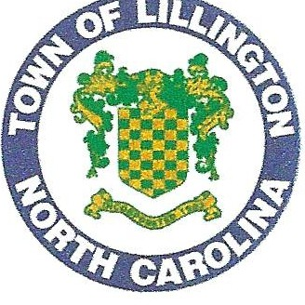

**TOWN OF LILLINGTON**

**2022 Annual Drinking Water Quality Report**

Water System Number: **NC 03-43-025**

We are pleased to present to you this year's Annual Drinking Water Quality Report (also known as the Consumer Confidence Report [CCR]). This report provides a snapshot oflast year's water quality. Included are details about the source of your water, any compounds detected during monitoring, and how it compares to standards set by regulatory agencies. Our constant goal is to provide you with a safe and dependable supply of drinking water. We are committed to providing you this information.

Our goal is to provide our customers with safe and dependable drinking water. Town staff continually seeks to improve the water quality and to protect our water resources. We are committed to ensuring the quality of our customer's water. We want our valued

I

customers to be fully informed about their water utility.

**What EPA Wants You to Know**

Drinking water, including bottled water, may reasonably be expected to contain at least small amounts of some contaminants. The presence of contaminants does not necessarily indicate that water poses a health risk. More information about contaminants and potential health effects can be obtained by calling the Environmental Protection Agency's Safe Drinking Water Hotline (800-426- 4791).

Some people may be more vulnerable to contaminants in drinking water than the general population. lmmuno-compromised persons such as persons with cancer undergoing chemotherapy, persons who have undergone organ transplants, people with HIV/AIDS or other immune system disorders, some elderly, and infants can be particularly at risk from infections. These people should seek advice about drinking water from their health care providers. EPA/CDC guidelines on appropriate means to lessen the risk of infection by *Cryptosporidium* and other microbial contaminants are available from the Safe Drinking Water Hotline (800-426-4791).

If present, elevated levels of lead can cause serious health problems, especially for pregnant women and young children. Lead in drinking water is primarily from materials and components associated with service lines and home plumbing. The Town of Lillington is responsible for providing high quality drinking water, but cannot control the variety of materials used in plumbing components.

When your water has been sitting for several hours, you can minimize the potential for lead exposure by flushing your tap for 30 seconds to 2 minutes before using water for drinking or cooking. If you are concerned about lead in your water, you may wish to have your water tested. Information on lead in drinking water, testing methods, and steps you can take to minimize exposure is available from the Safe Drinking Water Hotline or at [http://www.epa.gov/safewater/lead.](http://www.epa.gov/safewater/lead)

The sources of drinking water (both tap water and bottled water) include rivers, lakes, streams, ponds, reservoirs, springs, and wells. As water travels over the surface of the land or through the ground, it dissolves naturally-occurring minerals and, in some cases, radioactive material, and can pick up substances resulting from the presence of animals or from human activity. Contaminants that may be present in source water include microbial contaminants, such as viruses and bacteria, which may come from sewage treatment plants, septic systems, agricultural livestock operations, and wildlife; inorganic contaminants, such as salts and metals, which can be naturally-occurring or result from urban storm water runoff, industrial or domestic wastewater discharges, oil and gas production, mining, or farming; pesticides and herbicides, which may come from a variety of sources such as agriculture, urban storm water runoff, and residential uses; organic chemical contaminants, including synthetic and volatile organic chemicals, which are by-products of industrial processes and petroleum production, and can also come from gas stations, urban storm water runoff, and septic systems; and radioactive contaminants, which can be naturally-occurring or be the result of oil and gas production and mining activities.

In order to ensure that tap water is safe to drink, EPA prescribes regulations which limit the amount of certain contaminants in water provided by public water systems. FDA regulations establish limits for contaminants in bottled water, which must provide the same protection for public health.

**102 East Front Street• P.O. Box 296** • **Lillington, North Carolina 27546 Phone: (910) 893-2654** • **Fax (910) 893-3693** • [**www.lillingtonnc.org**](http://www.lillingtonnc.org/)

**When you turn on your tap, please consider the source**

Lillington's drinking water is purchased from Hamett Regional Water. The water plant is located at 310 West Duncan St, Lillington, NC 27546. Please read the attached Hamett Regional Water 2022 CCR for the location of their source and additional information.

**Violations That Our Water System Received for the Report Year**

* During 2022, the Town of Lillington received no violation.

**Water Quality Data Tables of Detected Contaminants**

The Town Of Lillington and Hamett Regional Water routinely monitors for over 150 contaminants in your drinking water according to Federal and State laws. The table below lists all the drinking water contaminants that were detected for the Lillington Water System for the 2022 year. The presence of contaminants does not necessarily indicate the water poses a health risk.

**Microbiolo2ical Contaminants in the Distribution Svstem** - For systems that collect ***less than 40*** samples per month

|  |  |  |  |  |  |
| --- | --- | --- | --- | --- | --- |
| Contaminant (units) | MCL  Violation  YIN | Your Water | MCLG | MCL | Likely Source of Contamination |
| Total Coliform Bacteria (presence or absence) | N | 0 | *NIA* | TT* | Naturally present in the environment |
| *E. coli*  (presence or absence) | N | 0 | 0 | Routine and repeat samples are total coliform-positive and either is *E. coli-*  positive or system fails to take repeat samples following *E.* coli-positive routine sample or system fails to analyze total coliform-positive repeat sample for *E. coli*  Note: If either an original routine sample and/or its repeat samples(s) are *E. coli* positive, a Tier I violation exists. | Human and animal fecal waste |

* If a system collecting fewer than 40 samples per month has two or more positive samples in one month, an assessment is required.

**Disinfectant Residuals Summary**

|  |  |  |  |  |  |  |  |
| --- | --- | --- | --- | --- | --- | --- | --- |
|  | Year Sampled | MRDL  Violation  *VIM* | Your Water  (highest RAA) | Range  Low High | MRDLG | MRDL | Likely Source of Contamination |
| Chlorine (ppm) | 2022 | N | 0.21 | .2 - 1.1 | 4 | 4.0 | Water additive used to control microbes |
| Chloramines (ppm) | 2022 | N | 2.89 | 1.6 - 3.8 | 4 | 4.0 | Water additive used to control microbes |

**Stae:e 2 Disinfection Byproduct Compliance** - Based upon Locational Running Annual Average (LRAA)

|  |  |  |  |  |  |  |  |
| --- | --- | --- | --- | --- | --- | --- | --- |
| Disinfection Byproduct | Year Sampled | MCL  Violation  *YIN* | Your Water  (highest LRAA) | Range  Low High | MCLG | MCL | Likely Source of Contamination |
| TTHM (ppb) | 2022 | N | 33.3 |  | *NIA* | **80** | Byproduct of drinking  water disinfection |
| Location (BO!) | 2022 | N |  | 20.8-48.5 | *NIA* | 80 | Byproduct of drinking  water disinfection |
| Location (B02) | 2022 | N |  | 19.1-52.9 | *NIA* | 80 | Byproduct of drinking  water disinfection |
| *HAAS* (ppb) | 2022 | **N** | 18.0 |  | *NIA* | 60 | Byproduct of drinking  water disinfection |
| Location (BO I) | 2022 | N |  | 10.1 -20.3 | *NIA* | 60 | Byproduct of drinking  water disinfection |

Location (B02)

2022 N 14.1 - 25.0 *NIA* 60

Byproduct of drinking water dis infection

**TTHM=Tribalomethanes HAAS=Halo acetic Acids**

**Asbestos Contaminant**

|  |  |  |  |  |  |  |  |
| --- | --- | --- | --- | --- | --- | --- | --- |
| Contaminant (units) | Sample Date | MCL  Violation  YIN | Your Water | Range  Low High | MCLG | MCL | Likely Source of Contamination |
| Total Asbestos (MFL) | 2022 | N | Not Detected | NA | 7 | 7 | Decay of asbestos cement water mains; erosion of natural deposits |

**Lead and Conner Contaminants**

|  |  |  |  |  |  |  |  |
| --- | --- | --- | --- | --- | --- | --- | --- |
| Contaminant (units) | Sample Date | Your Water (90th Percentile) | Number of sites found above the AL |  | MCLG | AL | Likely Source of Contamination |
| Copper (ppm) (90th percentile) | 2022 | 0.090mg/L | 0 |  | 1.3 | AL=l.3 | Corrosion of household plumbing systems; erosion of natural deposits |
| Lead (ppb) (90th percentile) | 2022 | Not Detected | NA |  | 0 | AL=J5 | Corrosion of household plumbing systems; erosion of natural deposits |

If you have questions about this report or concerning your water, please contact Brian Hyde Public Works Assistant Director at (910) 893-2654 or at [**byhde@lillingtonnc.org**](mailto:byhde@lillingtonnc.org)

## Important Drinking Water Definitions:

**Not-Applicable (NA)** - Information not applicable/ not required for that particular water system or for that particular rule.

**Non-Detects (ND)** - Laboratory analysis indicates that the contaminant is not present at the level of detection set for the particular methodology used. **Parts per million (ppm) or Milligrams per liter (mg/L)** - One part per million corresponds to one minute in two years or a single penny in $10,000. **Parts per billion (ppb) or Micrograms per liter (ug/L)** - One part per billion corresponds to one minute in 2,000 years, or a single penny in $10,000,000. **Million Fibers per Liter (MFL)** - Million fibers per liter is a measure of the presence of asbestos fibers that are longer than IO micrometers.

**Action Level (AL)** - The concentration of a contaminant which, if exceeded, triggers treatment or other requirements which a water system must follow.

**Treatment Technique (TT)** - A required process intended to reduce the level of a contaminant in drinking water.

**Maximum Residual Disinfection Level (MRDL)** - The highest level of a disinfectant allowed in drinking water. There is convincing evidence that addition of a disinfectant is necessary for control of microbial contaminants.

**Maximum Residual Disinfection Level Goal (JVlRDLG)** - The level of a drinking water disinfectant below which there is no known or expected risk to health. MRDLGs do not reflect the benefits of the use of disinfectants to control microbial contaminants.

**Locational Running Annual Average (LRAA)** - The average of sample analytical results for samples taken at a particular monitoring location during the previous four calendar quarters under the Stage 2 Disinfectants and Disinfection Byproducts Rule.

**Maximum Contaminant level (MCL)** - The highest level of a contaminant that is allowed in drinking water. MCLs are set as close to the MCLGs as feasible using the best available treatment technology.

**Maximum Contaminant Level Goal (MCLG)** - The level of a contaminant in drinking water below which there is no known or expected risk to health. MCLGs allow for a margin of safety.

***2022 Annual Drinking Water Quality Report Lillington Water System I Riverbluff***

***PWS ID# NC 50-43-002***

We are pleased to present to you this year's Annual Drinking Water Quality Report (also known as the Consumer Confidence Report [CCR]). This report provides a snapshot of last year's water quality. Included are details about the source of your water, any compounds detected during monitoring, and how it compares to standards set by regulatory agencies. Our constant goal is to provide you with a safe and dependable supply of drinking water. We are committed to providing you this information.

# When You Turn on Your Tap, Consider the Source

The water used by this system comes from the Town of Lillington and is surface water that is purchased from Harnett Regional Water. Please read the attached Harnett Regional Water 2022 CCR for the location of their source.

# Violations That Our Water System Received for the Report Year

During 2022, Riverbluffreceived no monitoring violations. All samples are now up to date.

# Water Quality Data Table of Detected Contaminants

The Town of Lillington and Hamett Regional Water routinely monitor for over 150 contaminants in your drinking water according to Federal and State laws. The table below lists all the drinking water contaminants that were detected in Riverbluff for the 2022 year. The presence of contaminants does not necessarily indicate that water poses a health risk.

**Stage 2 Disinfection Bvproduct Compliance** - Based upon Locational Running Annual Average (LRAA)

|  |  |  |  |  |  |  |  |
| --- | --- | --- | --- | --- | --- | --- | --- |
| Disinfection Byproduct | Year Sampled | MCL  Violation | Your Water  (highest LRAA) | Range  Low High | MCLG | MCL | Likely Source of Contamination |
| TTHM (ppb) |  | *YIN* |  |  |  |  |  |
|  |  |  |  |  |  |  |  |
| BO! | 2022 | N | 36.9 | 22.6 54.1 | *NIA* | 80 | Byproduct of drinking  water disinfection |
|  |  |  |  |  |  |  |  |
| HAAS (ppb) |  |  |  |  |  |  |  |
| BO! | 2022 | N | 18.1 | 14.9 20.7 | *NIA* | 60 | !Byproduct of drinking ater disinfection |
|  |  |  |  |  |  |  |  |

**TTHM=Trihalomethanes HAA5=Halo acetic Acids**

**Disinfectant Residuals Summary**

|  |  |  |  |  |  |  |  |
| --- | --- | --- | --- | --- | --- | --- | --- |
| **Contaminant (units)** | **Year Sampled** | **MRDL**  **Violation**  ***YIN*** | **Your Water (highes tRAA)** | **Range (low-high)** | **MRDLG** | **MRDL** | **Likely Source of Contamination** |
| Chloramines (ppm) | 2022 | N | 2.42 | 1.90-2. | 4 | 4.0 | Water additive used to control microbes |
| Free Chlorine (ppm) (March Only) | 2022 | N | 2 | 2-2 | 4 | 4.0 | Water additive used to control microbes |

**Lead and Copper Contaminants**

|  |  |  |  |  |  |  |  |
| --- | --- | --- | --- | --- | --- | --- | --- |
| Contaminant (units) | Sample Date | Your Water (90th Percentile) | Number of sites found above the  AL |  | MCLG | AL | Likely Source of Contamination |
| Copper (ppm) (90th percentile) | 2022 | Not Detected | 0 |  | 1.3 | AL=l.3 | Corrosion of household plumbing systems; erosion of natural deposits |
| Lead (ppb) (90th percentile) | 2022 | Not Detected | NA |  | 0 | AL=l5 | Corrosion of household plumbing systems; erosion of natural deposits |

**Definitions**

Not-Applicable (N/A) Parts per Billion (ppb) Parts per Million (ppm) Running annual average (RAA) Locational Running Annual Average (LRAA)-The average of sample analytical results for samples taken at a particular monitoring location during the previous four calendar quarters under the Stage 2 Disinfectants and Disinfection Byproducts Rule.

Maximum Residual Disinfection Level Goal (MRDLG)-The level of a drinking water disinfectant below which there is no known or expected risk to health. MRDLGs do not reflect the benefits of the use of disinfectants to control microbial contaminants.

Maximum Residual Disinfection Level (MRDL)-The highest level of a disinfectant allowed in drinking water. There is convincing evidence that

addition of a disinfectant is necessary for control of microbial contaminants.

Maximum Contaminant Level (MCL)-The highest level of a disinfectant that is allowed in drinking water. MCLs are set as close to the MCLGs as feasible using the best available treatment technology.

Maximum Contaminant Level Goal (MCLG)-The level of a contaminant in drinking water below which there is no known or expected risk to

health. MCLGs allow for a margin of safety. CCR- Consumer Confidence Report

Non Detected (N/0)

Protection of drinking water is everyone's responsibility. You can help protect your community's drinking water sources in several ways: Dispose of chemicals properly, take used motor oil to a recycling center, volunteer in your community to participate **in** group efforts to protect your source, etc.

If you have any questions about this report or concerning your water, please contact Brian Hyde (bhyde@lillingtonnc.org), Town of Lillington, at 910-893-2654. We want our customers to be informed about their water quality.

**Please read the attached 2020 Annual Drinking Water Quality Report for the Town of Lillington and Harnett Regional Water to find out more about the quality of your drinking water and other information about your drinking water.**

***2022 Annual Drinking Water Quality Report Lillington Water System*** - ***Vandercroft***

***PWS ID# NC 50-43-003***

We are pleased to present to you this year's Annual Drinking Water Quality Report (also known as the Consumer Confidence Report [CCR]). This report provides a snapshot oflast year's water quality. Included are details about the source of your water, any compounds detected during monitoring, and how it compares to standards set by regulatory agencies. Our constant goal is to provide you with a safe and dependable supply of drinking water. We are committed to providing you this information.

# When You Turn on Your Tap, Consider the Source

The water used by this system comes from the Town of Lillington and is surface water that is purchased from Harnett Regional Water. Please read the attached Hamett Regional Water 2022 CCR for the location of their source.

# Violations That Our Water System Received for the Report Year

During 2020, Vandercroft received no monitoring violations. All samples are now up to date.

# Water Quality Data Table of Detected Contaminants

The Town of Lillington and Harnett County Regional Water routinely monitors for over 150 contaminants in your drinking water according to Federal and State laws. The table below lists all the drinking water contaminants that were detected in Vandercroft for the 2022 year. The presence of contaminants does not necessarily indicate that water poses a health risk.

**Stage 2DIS'I"D £ecfIOU ByprodUCt Comp**r**1ance** - Based upon Locat10nalR unmng AnnualA verage (LRAA)

|  |  |  |  |  |  |  |  |  |  |
| --- | --- | --- | --- | --- | --- | --- | --- | --- | --- |
| Disinfection Byproduct | Year Sampled | MCL  Violation YIN | Your Water  (highest LRAA) | Low | Range  High | | MCLG | MCL | Likely Source of Contamination |
| TTHM (ppb) |  |  | 39.0 |  | | | *NIA* | 80 | Byproduct of drinking water  disinfection |
| B01 | 2022 | N |  | 25.6 | - | 57.3 |  |  |  |
| B02 | 2022 | N |  | 18.1 | - | 59.2 |  |  |  |
| HAAS (ppb) |  |  | 18.2 |  | | | N/A | 60 | Byproduct of drinking water  disinfection |
| BO! | 2022 | N |  | 12.8 | - | 20.9 |  |  |  |
| B02 | 2022 | N |  | 9.3 | - | 22.9 |  |  |  |

**TTHM=Trihalomethanes HAAS=Halo** acetic **Acids**

**Disinfectant Residuals Summary**

|  |  |  |  |  |  |  |  |  |  |  |  |
| --- | --- | --- | --- | --- | --- | --- | --- | --- | --- | --- | --- |
| **Contaminant (units)** | **Year Sampled** | **MRDL**  **Violation**  ***YIN*** | **Your Water (highes**  **t RAA)** | **Range (low-high)** | | | **MRDLG** | **MRDL** | **Likely Source Contamination** | | of |
| Chloramines (ppm) | 2022 | N | 3.70 | 2.5 | - | 3.2 | 4 | 4.0 | Water additive  control microbes | used | to |
| Free Chlorine (ppm) (March Only) | 2022 | N | 1.8 | 1.8 | - | 1.8 | 4 | 4.0 | Water additive control microbes | used | to |

**Lead and Copper Contaminants**

|  |  |  |  |  |  |  |  |
| --- | --- | --- | --- | --- | --- | --- | --- |
| Contaminant (units) | Sample Date | Your Water (90tl• Percentile) | Number of sites found above the AL |  | MCLG | AL | Likely Source of Contamination |
| Copper (ppm) (90th percentile) | 2022 | Not Detected | NA |  | 1.3 | AL=l.3 | Corrosion of household plumbing systems; erosion of natural deposits |
| Lead (ppb) (90th percentile) | 2022 | Not Detected | NA |  | 0 | AL=l5 | Corrosion of household plumbing systems; erosion of natural deposits |

**Definitions**

Non Detected (N/D)

Not-Applicable *(NIA)* Parts per Billion (ppb) Parts per Million (ppm) Running annual average (RAA) Locational Running Annual Average (LRAA)-The average of sample analytical results for samples taken at a particular monitoring location during the previous four calendar quarters under the Stage 2 Disinfectants and Disinfection Byproducts Rule.

Maximum Residual Disinfection Level Goal (MRDLG)-The level of a drinking water disinfectant below which there is no known or expected risk to health. MRDLGs do not reflect the benefits of the use of disinfectants to control microbial contaminants.

Maximum Residual Disinfection Level (MRDL)-The highest level of a disinfectant allowed in drinking water. There is convincing evidence that addition of a disinfectant is necessary for control of microbial contaminants.

Maximum Contaminant Level (MCL)-The highest level of a disinfectant that is allowed in drinking water. MCLs are set as close to the MCLGs

as feasible using the best available treatment technology.

Maximum Contaminant Level Goal (MCLG)-The level of a contaminant in drinking water below which there is no known or expected risk to health. MCLGs allow for a margin of safety.

CCR- Consumer Confidence Report

Protection of drinking water is everyone's responsibility. You can help protect your community's drinking water sources in several ways: Dispose of chemicals properly, take used motor oil to a recycling center, volunteer in your community to participate in group efforts to protect your source, etc.

If you have any questions about this report or concerning your water, please contact Brian Hyde, Town of Lillington, at [910-893-2654.(bhvde@lillingtonnc.org](mailto:910-893-2654.(bhvde@lillingtonnc.org) ). we want our customers to be informed about their water quality.

**Please read the attached 2022 Annual Drinking Water Quality Report for the Town of Lillington and Harnett Regional Water to find out more about the quality of your drinking water and other information about your drinking water.**

***2022: Drinking Water Analysis***

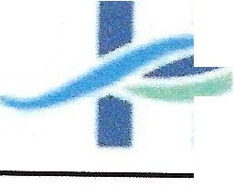

* **Harnett**

Regional

* Water

***Water Quality Report***

**Harnett County Regional WTP (PWS** ID# **03-43-045)**

We are pleased to present to you this year's Annual Drinking Water Quality Report. This report is a snapshot of last year's water quality. Included are details about from where your water comes, what it contains, and how it compares to standards set by regulatory agencies. Our constant goal is to provide you with a safe and dependable supply of drinking water. We want you to understand the efforts we make to continually improve the water treatment process and protect our water resources. We are committed to ensuring the quality of your water and to providing you with this information, because informed customers are our best allies. If you have questions about this report or concerning your water, please contact Tracy Tant, 910-893-7575 ext. 3245. We want our valued customers to be informed about their water utility. If you want to learn more, please attend any *of* the regularly scheduled Harnett County Board *of* Commissioners' meetings. They are held on the first and third Monday of each month at the Harnett County Resource Center and Library at 455 McKinney Parkway in Lillington, NC. The first meeting of the month is normally at 9:00 AM and the midmonth meeting normally begins at 6:00 PM.

### *What EPA Wants You to Know Source Water Assessment Program (SWAP) Results*

Drinking water, including bottled water, may reasonably be expected to contain at least small amounts of some contaminants. The presence of contaminants does not necessarily indicate that water poses a health risk. More information about contaminants and potential health effects can be obtained by calling the Environmental Protection Agency's Safe Drinking Water Hotline (800-426-4791).

Some people may be more vulnerable to contaminants in drinking water than the general population. lmmunocompromised persons such as persons with cancer undergoing chemotherapy, persons who have undergone organ transplants, people with HIV/AIDS or other immune system disorders, some elderly, and infants can be particularly at risk from infections. These people should seek advice about drinking water from their health care providers. EPA/CDC guidelines on appropriate means to lessen the risk of infection by Cryptosporidium and other microbiological contaminants are available from the Safe Drinking Water Hotline (800-426-4791).

If present, elevated levels of lead can cause serious health problems, especially for pregnant women and young children. Lead in drinking water is primarily from materials and components associated with service lines and home plumbing. Harnett County is responsible for providing high quality drinking water, but cannot control the variety of materials used in plumbing components. When your water has been sitting for several hours, you can minimize the potential for lead exposure by flushing your tap for 30 seconds to 2 minutes before using water for drinking or cooking. If you are concerned about lead in your water, you may wish to have your water tested. Information on lead in drinking water, testing methods, and steps you can take to minimize exposure is available from the Safe Drinking Water Hotline or at [http:f/www.epa.gov/safewater/lead.](http://f/www.epa.gov/safewater/lead)

The sources of drinking water (both tap water and bottled water) include rivers, lakes, streams, ponds, reservoirs, springs, and wells. As water travels over the surface of the land or through the ground, it dissolves naturally-occurring minerals and, in some cases, radioactive material, and can pick up substances resulting from the presence of animals or from human activity.

Contaminants that may be present in source water include microbial contaminants, such as

viruses and bacteria, which may come from sewage treatment plants, septic systems, agricultural livestock operations, and wildlife; inorganic contaminants, such as salts and metals, which can be naturally-occurring or result from urban storm water runoff, industrial or domestic wastewater discharges, oil and gas production, mining, or farming; pesticides and herbicides, which may come from a variety of sources such as agriculture, urban storm water runoff, and residential uses; organic chemical contaminants including synthetic and volatile organic chemicals, which are by-products of industrial processes and petroleum production, and can also come from gas stations, urban storm water runoff, and septic systems; and radioactive contaminants which can be naturally-occurring or be the result of oil and gas production and mining activities

In order to ensure that tap water is safe to drink, EPA prescribes regulations, which limit the amount of certain contaminants in water provided by public water systems. FDA regulations establish limits for contaminants in bottled water, which must provide the same protection for public health.

### *When You Turn on Your Tap, Consider the Source*

The Water that is used by this system comes from the Cape Fear River, which is formed by the confluence of the Deep, and Haw River along the border between Chatham and Lee counties. We are a surface water treatment plant located at 310 West Duncan St. in Lillington NC.

The North Carolina Department of Environment Quality (DEQ), Public Water Supply (PWSS) Section, Source Water Assessment Program (SWAP) conducted assessments for all drinking water sources across North Carolina. The purpose of the assessment was to determine the susceptibility of each drinking water source (well or surface water intake) to Potential Contaminant Sources (PCSs).

The relative susceptibility rating for Harnett Regional Water (HRW) was determined by combining the contaminant rating (number and locations of PCSs within the assessment area) and the inherent vulnerability rating (i.e., characteristics or existing conditions of watershed and its delineated assessment area.) The assessment findings are summarized in the table below·

|  |  |  |
| --- | --- | --- |
| **SWAP Result Summary** | | |
| Source Name | Susceptibility Rating | SWAP Report Date |
| CAPE FEAR RIVER | Moderate | 9/10/2020 |
| DUNN/CAPE FEAR RIVER | Higher | 9/10/2020 |

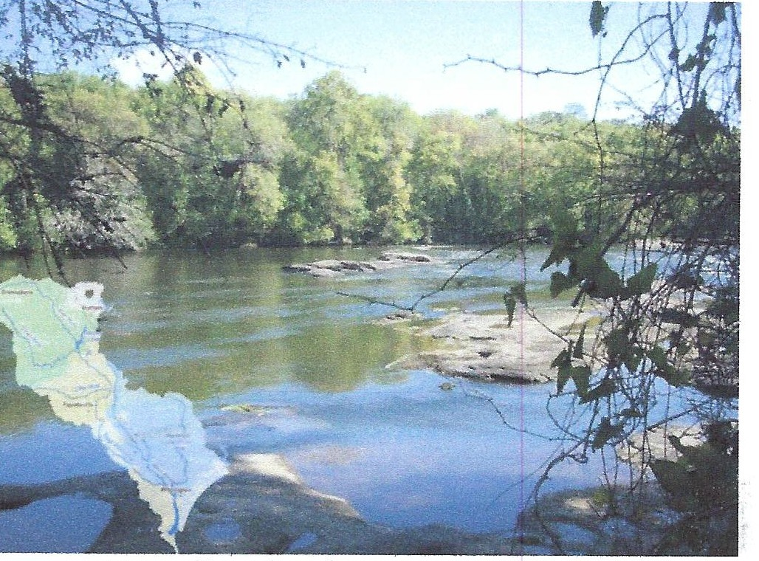

Harnett Regional Water-Cape Fear River

The Complete SWAP Assessment report for Harnett Regional Water may be viewed on the website: [*https:/fwww.ncwater.org/?paqe:;;;;60Q*](http://www.ncwater.org/?paqe%3A%3B%3B%3B%3B60Q)Note that because SWAP results and reports are periodically updated by the PWS section, the results may differ from the results on the CCR. To obtain a printed copy of this report, please mail a written request to: Source Water Assessment Program - Report Request, 1634 Mail Service Center, Raleigh NC 27699-1634, or email request to [*swap@ncdenr.gov.*](mailto:swap@ncdenr.gov)Please indicate System Name (Harnett Regional Water) PWSID (03-43-045), and provide your name, mailing address and phone number. If you have any questions about the SWAP report, please contact the Source Water Assessment staff by phone at 919-707-9098.

It is important to understand that a susceptibility rating of "higher" does not imply poor water quality, only the systems' potential to become contaminated by PCS's in the assessment area.

*Director's Corner Additional Information*

HRW experienced a very productive year in 2022. Harnett County continues to grow at an astounding pace with many new planned residential developments underway. HRW is busy planning to accommodate this growth to ensure our ability to provide our customers with outstanding water and sewer service well into the future. Our multi-year water meter upgrade project is currently approximately 80% complete. We were hoping to be at 100% by this time but supply chain issues brought about by the COVID-19 pandemic completely stopped our progress for 9 months. HRW is replacing all of our existing water meters with new digital meters that transmit hourly readings to our customer service department. The new system uses wireless and radio frequency technology to transmit the readings eliminating the need for manual reads. This new technology will allow HRW to alert customers to leaks and other possible issues much faster saving them money and conserving water in the process. HRW will continue to keep you informed of the project status and how you can benefit from these improvements.

We are very proud of our record of environmental compliance as evidenced by this water quality report. We did not have any water quality violations and produced excellent water for our customers as always. Contact us by email or phone to get your water treatment questions answered. HRW is very fortunate to have such a fine group of water treatment professionals who strive daily to provide only the best drinking water to all of our citizens. HRW will continue to serve the citizens of Harnett County and the surrounding region by supplying only the best of the most important commodity in the world, water.

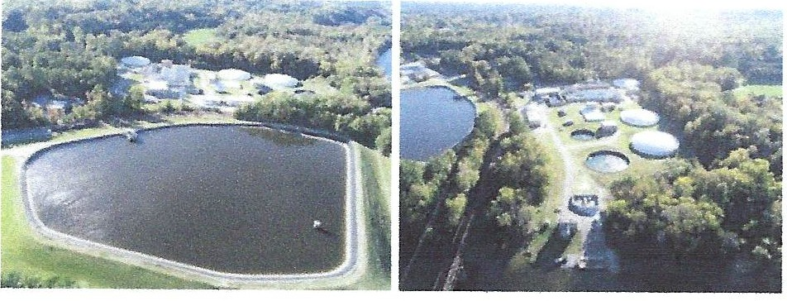

. We routinely monitor for over 150 contaminants in your drinking water according to Federal and State laws. The following tables list the contaminants detected in the last round of sampling. The presence of contaminants does not necessarily indicate that water poses a health risk. Unless otherwise noted, the data presented in these tables are from testing done January 1 through December 312022. The EPA and the State allow us to monitor for certain contaminants less than once per year because the concentrations of these contaminants are not expected to vary significantly from year to year. Some of the data, though representative of the water quality, is more than one year old. In these tables you will find many terms and abbreviations you might not be familiar with. To help you better understand these terms we've provided the following definitions:

*PPM -Parts per Million* - *One part per million corresponds to one minute in two years or a single penny in $10,000.*

*PPB* - *Parts per Billion* - *One part per billion corresponds to one minute in* 2,000 *years, or a single penny in $10,000,000.*

*pCi/L* - *Picocudes per liter* - *Picocuries per liter is a measure of the radioactivity in water.*

*NTU* - *Nephelametric Turbidity Unit* - *Nephelometric turbidity is a measure of water clarity. Turbidity in excess of 5 NTU is just noticeable to average person*

*ND* - *Non-Detect* - *Laboratory analysis indicates that the contaminant is not present at level of detection set for the particular methodology used.*

*NA* - *Not Applicable* - *Information not applicable/not required for that particular water system or for that particular rule.*

*MCLG* - *Maximum Contaminant Level Goal* - *The level of a contaminant in drinking water below which there is no known or expected health risk. MCLGs affow for a margin of safety.*

*MCL* - *Maximum Contaminant Level- The highest level of a contaminant that is o/fowed in drinking water. MCLs are set as close to MCLGs asfeasible using the best available Treatment technology. SMCL -Secondary Maximum Contaminant Level*

*TT- Treatment Technique* - *is a required process intended to reduce the level of contaminant in drinking water.*

*AL* - *Action Level* - *The concentration of a contaminant which, if exceeded triggers treatment or*

*other requirements which a water system must follow.*

*MFL-Million Fibers per Liter A measurement of the presence of asbestos fibers that are longer than 10 micrometers*

*LRM* - *Locational Running Annual Average* - *The average of sample analytical results for samples taken at a particular monitoring location during the previous four calendar quarters under the Stage 2 Disinfectants and Disinfection Byproducts Rule*

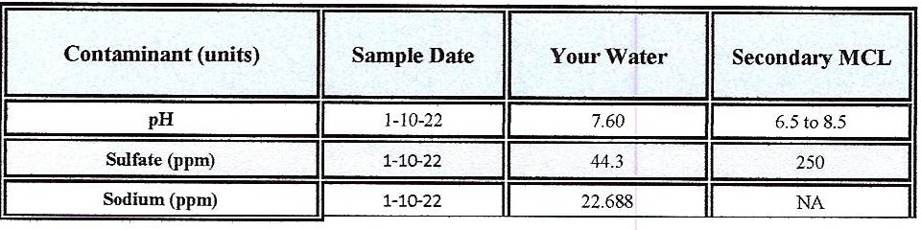Step 1 TOC Removal Requirements Misc, Water Characteristics Contaminants

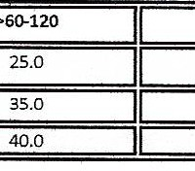

Soun:e Water TOC(Mg/L)

Sou

0-60

>120

>2.0-4.0

35.0

15.0

>4.0-8.0

>8.0

45.0

so.a

25.0

30.0

#### Turbidity

|  |  |
| --- | --- |
| Treatment Technique (TT) Violation if: | Likely Source |
| Turbidil > I NfU  Tmt,idi mcasuremmts are 0.3 NTU | Soilnmoff |

*Turbidity is a measure of the cloudiness of the water. We monitor it because it* is *a good indicator of the effectNeness of ourfiltration system, The turbidity rule requires that* 95% *or more of the monthly samples must be less than or equal to 0.3 NTU*

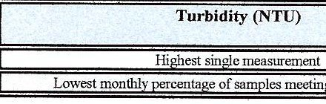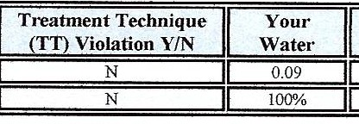

#### Microbiological Contaminants

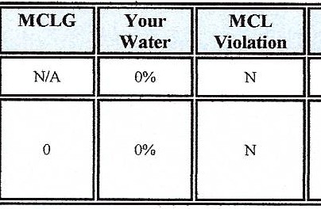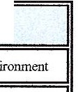

Likely Source of Contamination

Naturally present in the en

Human and Animal Fecal Waste

|  |  |  |
| --- | --- | --- |
|  |  | MCL |
|  | > *5* % triggers level J assessment |
| 1- ecal Coliform or E. coli (p:esence or absence) | | Routine Hild repeat samples are total coliform-positive and either is E. coli-positive or system fails to take repeal samples following E. coli-positive routine Sflmple or system fails to analyze total coliform-positive repeat sampl for E. coli  Nott:: lfcitheranoci itive a Tier I violation exists. |

Regulated Inorganic Contaminants

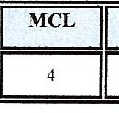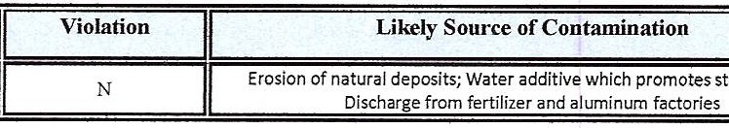

Contaminant (units)

MCLG

Your Water

Range

Date of Sample

Fluoride (ppm)

0.62

*NIA*

1/10/22

|  |  |
| --- | --- |
| Contaminant [code] (units) |  |
| Copper (ppm) 90111Percentile |  |
| Lead (ppb) 90111Percentile |  |

|  |  |  |  |
| --- | --- | --- | --- |
|  | Date of Sample |  |  |
|  |  |  |
|  | 8/2022-9/2022 | N | |

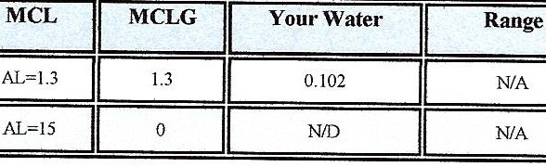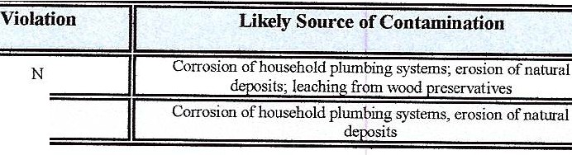Disinfection Residuals Summary

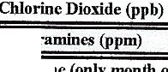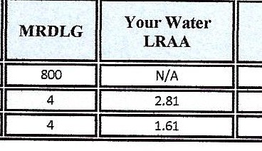

MRDL

2022

2022

800

Cltlo

.Chlorine (only month ofMarch)(ppm)

YEAR

Contaminant

|  |  |  |
| --- | --- | --- |
| Range Individual Results | MRDL  Violation | Likely Source of Contamination |
| Water additive used to control microbes | | |
| 1.0-4.2 | Water additive used to control microbes | |
| 0.2-3.4 | Water additive used to control microbes | |

Disinfection By-Product Precursors Contaminants

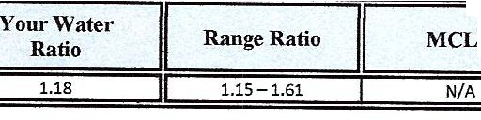

Contaminant (units)

TT Violation YIN

G

MCL

Likely Source of Contamination

Compliance Method

TT

Naturally present In the environment

Step 1

|  |  |  |  |  |
| --- | --- | --- | --- | --- |
| Contaminant | **YEAR** |  | | |
|  | 2022 |
|  |  |  |  | Sy-product of chlorination |
|  |  |  |  | By-product of chlorination |
|  |  |  |  | By-product of chlorination |
|  |  |  |  | By-product of chlorination |
|  |  |  |  | By-product of chlorination |
|  |  |  |  | B -product of chlorination |
|  |  |  |  | By-product of chlorination |
|  | 2022 |  |  | By-product of chlorination |
| HAAS (ppb) B02 | 2022 |  |  | By-product of chlorination |
| HM5 (ppb) 803 | 2022 |  |  | By-product of chlorination |
| HAA5 (ppb) 804 | 2022 |  |  | By-pr uct of chlorination |
|  | 2022 |  |  | By-product of chlorination |
|  | 2022 |  |  |  |
|  |  |  |  |  |
|  |  |  |  |  |
|  | 2022 |  |  |  |

*Some people who drink waler co11taining lrihalomell1a11es in excess of the A1CL over mony year.; may experience problems with their liver, kidneys, or central 11en;ous systems, mu/ may llffi'f! an increased risk of getting cancer Some people 1111() drink water co11taining haloacetic acidf in excess of the J,,fCL uver many years may have m, increased risk of getting cancer*

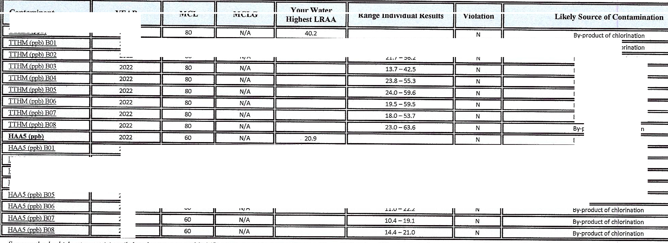

Other Disinfection Byproduct Contaminants

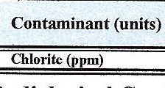

MCUMRDL

Violation Y?N

N

Your Water

0.46

Range

Low

0.20

High

0.49

MCLG

Radiological Contaminants

|  |  |  |  |  |  |  |  |  |  |  |  |
| --- | --- | --- | --- | --- | --- | --- | --- | --- | --- | --- | --- |
| Contaminant (units) | Sample Date | MCL Violation  *YIN* | Your Water | | II | MCLG | II | MCL | II | Likely Source of Contamination | II |
| Combined radium (oCi/L) | 10-12-21 | N | I | 1.1 | II | 0 | II | 5 | 11 | Erosion of natural deoosits | II |

## Water Quality Table(s) For City of Dunn PWS# 03-43-010 :2022

**urchased**

#### Turbidity

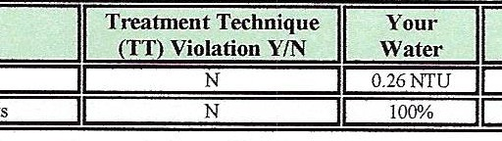Turbidity (NTU)

|  |  |  |
| --- | --- | --- |
| Treatment Technique (TI) Violation if: | Likely  Sour'Ce |  |
| Turbidity> I NTU | Soil runoff |
| Turbidi measurements are ::S 0.3 NTU |  |  |

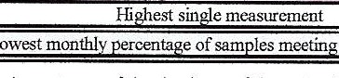

*Turbidity is a measure of the cloudiness of the water. We monitor it because it is a good indicator of the effectiveness of our filtration system. The turbidity rule requires that 95% or more of the monrh/y samples must be less than or equal to 0.3 NTU*

Inorganic Contaminants

|  |  |  |  |  |  |  |  |  |
| --- | --- | --- | --- | --- | --- | --- | --- | --- |
| Contaminant (units) | GtcJ | | MCL  Vrolation  *YIN* | Your Water | Range  Low High | MCLG | MCL | Likely Som'Ce of Contamination |
| Fluoride (ppm) II | | J,05122 II | N | I 0.79 |  |  |  | Erosion of natural dcpositi; water additive |
| 0. | | 4 | which (KOIDOtes strong teeth; discharge from fertiliz.er and aluminum factocies |

I

|  |  |  |  |
| --- | --- | --- | --- |
| ofsites found  vetheAL | **MCLG** | **AL** | Likely Source of Contamination |
|  | 1.3 | AL=l.3 | Corrosion ofbousehold plumbing systems;erosion ofnaturaldepos.it:s |
|  | | | Corrosion of household plumbing systems; erosion of natural deposits |
|  | | | |

**Radiological Contaminants**

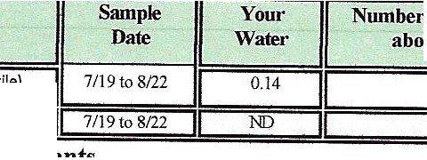

Contaminant (units)

Copper (ppm) (9:Jhpercentlle)

Lead(ppb) (9Cf'percentile)

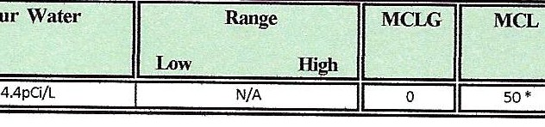

Contaminant (units) Sample Date

**MCL**

Violation YIN

i Beta/photon emitters (pCi/L) i

10/01/18

|  |  |
| --- | --- |
|  | Likely Source of Contamination |
|  | Decay of natural and man-made depo ts |

**Total Organic Carbon (IOC)**

|  |  |  |  |  |  |  |  |
| --- | --- | --- | --- | --- | --- | --- | --- |
| Contaminant (units) | IT  Violation  ***YIN*** | Your\Vater (RAA  Removal Ratio) | Range Monthly Removal Ratio  Low- High | **MCLG** | IT | Likely Source of Contamination | Compliance Method  **(Step** I **or ACC#_J** |
| Total Organic Carbon (removal ratio)(TOC)- TREATED | N | 1.15 | 0.92- 1.56 | N/A | D Naturally present in the environment | | stepl |

**Stage 2 Disinfection Byproduct Compliance** - Based upon Locational Running Annual Average (LRAA)

|  |  |  |
| --- | --- | --- |
|  |  |  |
|  |  |
|  |  |
|  |  | |
|  | 2Sppb | |
|  | 22ppb | |
|  | 25ppb | |
|  | 24ppb | |

**Disinfectant Residuals Summary**

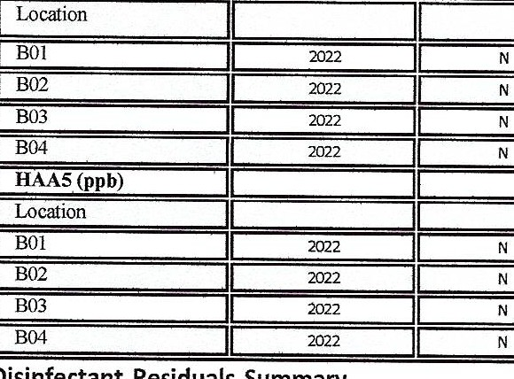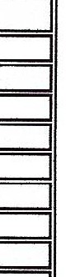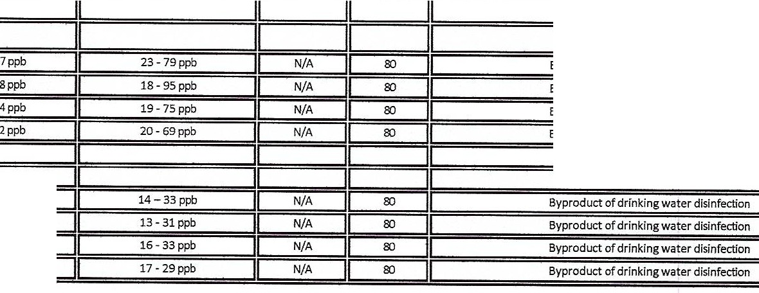

TTHM(ppb)

Byproduct of drinking water disinfection

Byproduct of drinking water disinfection Byproduct of drinking water disinfection

Likely Source of Contamination

MCL

MCLG

**High**

**Low**

Range

Your Water

**(highest LRAA)**

**MCL**

Violation

***YIN***

Year Sampled

D infection Byproduct

Syp aterdisinfectlon

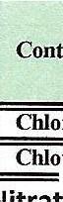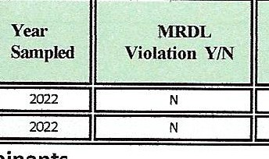

oramines (ppm)

|  |  |  |  |  |  |  |  |
| --- | --- | --- | --- | --- | --- | --- | --- |
| Your Water |  | Range |  | MRDLG | E] |  | Likely Source of Contamination |
| (highest RAA) | Low |  | High |  |  |
| 0.43ppm | 0.02 - 2.2PP"TI | | |  | 4.0 |  |  |
| 2.32ppm | 1.0 - 3.3 ppm | | | | .0 |  |

**Nitrate/Nitrite Contaminants**

|  |  |  |  |  |  |  |
| --- | --- | --- | --- | --- | --- | --- |
| Contaminant  **(units)** | Sample  Date | **MCL**  Violation  ***YIN*** | Your Water | **MCLG** | **MCL** | Likely Source of Contamination |
| Nitrale(a.s Nitrogen)  **ppm** | 2022 | **N** | 3.98 | **10** | 10 | Runoff from fertilizer use; !eaching from septic tanks, sewage; erosion of natural deposits |

Nitrate: *Nitrate m dnnking water at levels above10 ppm ,s o health nskfor ,nfonts of less than SIX months of age. High nitrate levels m drinking water can cause blue baby syndrome. Nitrate levels may nse quicklyfor short periods of time because of ramfall or agricultural activity. If you ore caringfor an infant you should ask advicefrom your health care provider.*

Other Miscellaneous Water Characteristics Contaminants

